Sri Lanka Institute of Information Technology



Lab Submission

<Lab Sheet No_03>

**<IT24102205>**

**<Wijekoon S. P. A. S. A.>**

### **Probability and Statistics | IT2120**

### B.Sc. (Hons) in Information Technology

**Exercise**

1. Import the dataset (‘Exercise.csv‘) into R and store it in a data frame called “student data”.

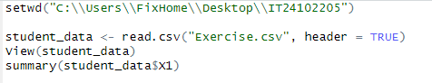

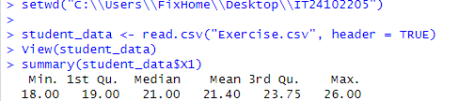

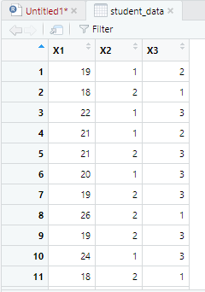

1. Produce the summary statistics and histogram for the variable “X1” (Age).

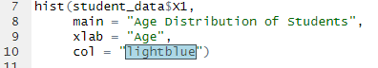



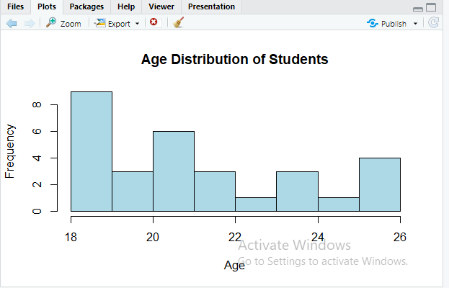

1. Create a bar chart and frequency table for “X2” (Gender).



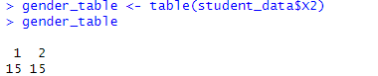

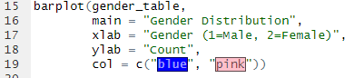

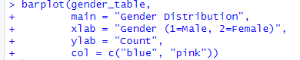

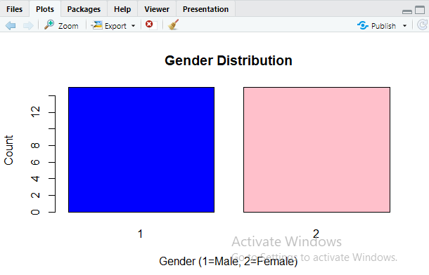

1. How does the age (X1) change according to the accommodation (X3)? Analyze it using a suitable graph and interpret the results. (Note that accommodation has three levels which are type 1, type 2 and type 3)

